

**Prevent policy**

|  |  |
| --- | --- |
| **Policy version** | **3** |
| **ID number** | **P002** |
| **Accountable** | **JH** |
| **Review date** | **November 2024** |

**Prevent Duty**

The government Counterterrorism and Security Act 2015, places a duty upon all education providers to have regard to the need to prevent people from being drawn into terrorism. This Prevent Duty forms part of the wider governments CONTEST counter terrorism strategy:

* Prevent terrorism – stop people becoming terrorists.
* Pursue terrorism – disrupt and stop terror attacks.
* Prepare to deal with terrorism – mitigate impact of attacks that can’t be stopped.

As a nation we continue to prioritise according to the threat posed to our national security; the allocation of resources will be proportionate to the threats we face. There has been an increase in far-right inspired terror attacks and lone acts of terror opposed to mass organised terror activities, the government strategy now includes ways in which to identify risk of these instances.

The aim of the Prevent Duty is to reduce the threat to the UK from terrorism by stopping people becoming terrorists or supporting terrorism. The Prevent Duty has three specific strategic objectives.

* Respond to the ideological challenge of terrorism and the threat we face from those who promote it
* Prevent people from being drawn into terrorism and ensure that they are given appropriate advice and support.
* Work with sectors and institutions where there are risks of radicalisation that we need to address.

**Our Objectives**

**APPROVED TRAINING as** a training provider has a responsibility to ensure:

* We have undertaken training in the Prevent Duty as identified by the Senior Management Team
* We are all aware of when it is appropriate to refer concerns about learners or colleagues to our Designated Safeguarding Officer and Designated Safeguarding Lead at Approved Training who will follow the Prevent and Channel Procedure
* To exemplify British Values of “democracy, the rule of law, individual liberty and mutual respect and tolerance for those with different faiths and beliefs” into our practice.

**Scope**

This policy relates to all staff and learners including those in our Supported Services and remaining sub-contractors.

**Key Contacts**

Designated Safeguarding Lead/Single Point of Contact (DSL/SPOC) APPROVED TRAINING

Janie Hewitt – Janieh@approvedtraining.net

**Department of Education** [**0207 340 7264**](tel:02073407264)[**counter.extremism@education.gov.uk**](mailto:counter.extremism@education.gov.uk)

**Prevent Coordinators - see (Key Contacts Appendix 1)**

**Definitions**

Radicalisation - is a process by which an individual or group comes to adopt increasingly extreme political, social, or religious ideals and aspirations that reject or undermine the status quo.

Terrorism - an act of terror/ violence based on a political objective, whether that means the politics of nationalism, ethnicity, or religion.

Extremism - an ideology that is far outside the mainstream attitudes of society, including vocal or active opposition to fundamental British Values, including democracy, the rule of law, individual liberty and mutual respect and tolerance of different faiths and beliefs. This also includes calls for the death of members of the British armed forces.

**Leadership and Governance**

Prevent forms part of the Safeguarding agenda which is featured as part of The Governance Advisory Board meetings. Approved training has a Designated Safeguarding Lead, leading the Prevent initiative, and the MD, Head of Finance, Head of training, Quality and Curriculum lead, Project manager are actively engaged within the Safeguarding and Prevent agenda. It has been well documented within current literature, namely the Prevent Strategy 2011 and Keeping Children Safe in Education, which protects people from being drawn into radicalisation, should align with the current safeguarding measures in place to protect learners from the risks of safeguarding issues. Prevent Duty is also embedded within IT, social media, social learning platforms and Safeguarding policies.

**Risk Management**

Counter Terrorism & Security Duty 2015: “to have due regard to the need to prevent people from being drawn into terrorism.

*Each institution should carry out a risk assessment which assesses where & how students & staff may be at risk of being drawn into terrorism.*”

Approved training will collate and disseminate information based on a Counter-terrorism Local Profile (CTLP) which is produced by each police force to provide an overview of the national, regional, and local risks from terrorism and extremism in each area.

Approved Training will use the information received from the CTLP, DfE Prevent Co-ordinators to inform its Prevent Risk Assessment.

**Staff Training**

All staff are trained on the vulnerabilities and indicators of radicalisation, the Channel Process and how the duty engages with requirements of their role, via online learning and ongoing Safeguarding training at Approved Training. Identifying risk at an early stage allows early intervention and is crucial to the Prevent Duty and Channel Process being successful.

There is a dedicated area within the Learning platform, Canvas, containing all legislative documents, policies, training materials, and additional resources to extend knowledge, challenge extremism and ideas to support the promotion of British Values. Training information will be updated in line with Government policy and training and resources updated accordingly.

There is annual CPD training, monthly topical newsletters, key to wellbeing topics and monthly regional updates sent to DSO’s for dissemination provided by the Designated Safeguarding Lead.

**Engagement with External Partners**

All employers will be made aware of Approved Training ’s Prevent processes and their duty by means of Designated Safeguarding Lead communication. Channels are in place to assist with meeting the Prevent Duty and avenues for raising concerns are established with Prevent coordinators available. (Designated Safeguarding Officers)

**Learner Safety, Engagement & Curriculum**

The duty encompasses building learner resilience to the threat of radicalisation, challenging extremism and raising awareness of and demonstrating British Values:

* Democracy
* Rule of law
* Tolerance and understanding of different faiths.
* Challenging discrimination
* Individual liberty

Opportunities to promote all of the above values are currently facilitated within the apprenticeships.  There is a dedicated area in Canvas for staff to access learning on Prevent and British Values.

**Extremism, Terrorism, and Radicalisation**

**Extremism** is when an individual or group have extreme views which may be hateful, dangerous or against the law.

**Terrorism** is when an individual or group of people use violence to harm and scare others.

**Radicalisation** is when an individual develops extreme views and ideologies that may lead towards causing harm to others. Children, young people and vulnerable adults are at risk of radicalisation and may display changes in their behaviours, views, and beliefs.

People have a right to express their opinions however, it becomes a concern to everybody, including families, schools, communities, and police, if a person begins to encourage or use violence to achieve a political, religious, or ideological goal.

**Recognising the indicators of vulnerability to radicalisation**

## **Domestic Extremism**

Domestic extremism refers to the activity of individuals or groups conducting criminal acts of direct action to further their protest campaign. This term covers the conduct of groups involved including the extreme right wing and animal rights extremists.

## **Violent Extremism**

Violent extremism refers to the activity of individuals or groups conducting acts by any means to express views which justify or glorify terrorist violence. This includes those that encourage others to commit terrorist acts or provoke others into terrorist related activity. It also includes those who foster hatred which may lead to inter-community tensions and violence within the United Kingdom.

## **Radicalisation**

Radicalisation is the process where a vulnerable young person or adult changes their perception and beliefs due to exposure of an extremist influence (which may be online, publication or one to one direct contact) to become more extremist in nature which may result in extremist actions.

There is no such thing as a “typical extremist”: those who become involved in extremist actions come from a range of backgrounds and experiences, and most individuals, even those who hold radical views, do not become necessarily involved in violent extremist activity.

Learners may be susceptible to radicalisation through a range of social, personal, and environmental factors – it is known that violent extremists exploit vulnerabilities in individuals to drive a wedge between them and their families and communities. It is vital that staff, employer, family, and friends are able to recognise those vulnerabilities.

**Indicators of Vulnerability Include:**

* Identity Crisis – the learner is distanced from their cultural/religious heritage and experiences discomfort about their place in society.
* Personal Crisis – The learner may be experiencing family tensions: a sense of isolation; and low self-esteem; they may have dissociated from their existing friendship group and become involved with a new and different group of friends; they may be searching for answers to questions about identity, faith and belonging.
* Personal Circumstances – migration; local community tensions; and events affecting the learner’s country or region of origin may contribute to a sense of grievance that is triggered by personal experience of racism, discrimination or aspects of government policy.
* Unmet Aspirations – the learner may have perceptions of injustice; a feeling of failure; rejection of civic life.
* Experiences of Criminality – which may include involvement with criminal group, imprisonment, and poor resettlement/reintegration.
* Special Educational Needs – the learner may experience difficulties with social interaction, empathy with others, understanding consequences of their actions and awareness of motivations of others.

**More critical risk factors could include:**

* Being in contact with extremist recruiters.
* Accessing violent extremist websites, especially those with a social networking element.
* Possessing or accessing violent extremist literature.
* Using extremist narrative and global ideology to explain personal disadvantage.
* Justifying the use of violence to solve societal issues.
* Joining or seeking to join extremist organisations.
* Significant changes in behaviour and/or appearance.
* Increased isolation or on-line presence.

People have a right to express their opinions however, it becomes a concern to everybody, including families, schools, communities, and police, if a person begins to encourage or use violence to achieve a political, religious, or ideological goal.

**Access & monitoring of IT systems**

In order to safeguard individuals from accessing extremist materials while using company equipment Approved Training will ensure:

* Appropriate staff are able to monitor any aspects of its mobile phones and computing facilities that are made available to staff, learners, and visitors.
* Only organisation approved software will be supported by the organisation and allowed to be used, and frequently checked by our IT system company.
* All unauthorised software that breaches organisation policy or presents a risk to staff or learner safety will be removed and appropriate action taken.
* All unusual or suspicious events, and any breaches of security are reported via the safeguarding reporting channels for further investigation.
* Approved training recognise that the highest number of learners are in work-based learning and can have little impact on learner access and IT use, however staff need to be vigilante to any behaviours or attitude changes and should discuss on-line safety and risk posed.

**Freedom of Speech**

Article 10 protects your right to hold your own opinions and to express them freely without government interference. (Equality and Human Rights Commission). Approved training shall uphold the fundamental rights of freedom of speech and expression so far as that is reasonably practical within the law.

“Every institution clearly needs to balance its legal duties in terms of both ensuring freedom of speech and also protecting student and staff welfare”.

Approved Training has a duty to maintain safety and good order for its staff, learners, and other stakeholders and to ensure that the articulation of beliefs, points of view and opinion do not lead to an offence or otherwise constitute or give rise to the potential to constitute incitement to riot or incitement to racial or religious hatred.

All persons to whom this Policy applies are required to observe the principles of freedom of speech and expression during meetings, learning sessions, events and any other business where persons represent Approved Training, and shall show respect and tolerance towards the expression of views, opinions and beliefs of others, even though those views, opinions or beliefs may run contrary to their own personal views, opinions or beliefs.

Any attitudes, behaviours or concerns which may affect others or learners should be reported to the DSL.

**External Speaker and Events**

When deciding whether or not to host a particular speaker, Approved training should consider carefully whether the views being expressed, or likely to be expressed, constitute extremist views that risk drawing people into terrorism or are shared by terrorist groups. Topics and materials should be discussed with the speaker and a risk assessment completed. Managers should ensure that, where any event or External Speaker is being allowed speakers with extremist views that could draw people into terrorism are challenged with opposing views as part of that same event, rather than in a separate forum. Where the risk cannot be fully mitigated, they should exercise caution and not allow the event and/or speaker to proceed. Offsite events and online events should be managed appropriately with an Approved training representative in attendance to confirm attendees and remove potential speakers or attendees from the meeting

**Referral Pathways**

If a learner has concerns about themselves, or you have concerns about a learner being at risk of radicalisation, you should complete a referral to the DSL/SPOC, by either phone or email: explaining the learners and/or your concern. Referral and recording your concerns allows the DSL/SPOC to support you or the learner, advise on next steps and escalate to external agencies any concerns.

**NB - should you feel your learner, yourself or any members of the public are in immediate danger report to the police immediately.**

Once the Designated Safeguarding Team has been informed, they will decide on whether the issue needs to be escalated to the local Police Prevent Officer.

The Designated Safeguarding Team/staff member that is involved with the referral will then support the Channel Process as seen fit by the local Channel panel. It should be noted that referral to the Channel Process is not a criminal intervention.

It should be noted that a learner displaying one or a few of the vulnerabilities and indicators does not mean the learner will necessarily be at risk of radicalisation, but it may do so.

**In all instances that concern you, you should report to the DSL**.

The process for referral to a prevent coordinator involves risk assessing the learner's level of engagement, intent, and capability. If guidance is required, the Designated Safeguarding Lead will discuss with a local FE Prevent Coordinator.

**Safeguarding Staff Members as a Result of Referral**

While it is unlikely that the referrer would then be targeted, if someone received a threat, or the police felt someone was under threat without them knowing, there are risk assessments, warning and safeguarding processes within local police departments that will apply as a matter of routine. The outcome might involve an investigation and arrests being made etc, such as markers on people’s mobile phone numbers or addresses, warnings to parties involved, or other measures.

**Key Prevent Contacts by Region**

**For Urgent Referrals:**

[Prevent and Channel factsheet - 2023 - Home Office in the media (blog.gov.uk)](https://homeofficemedia.blog.gov.uk/2023/02/08/prevent-and-channel-factsheet-2023/)

**FE/HE Regional Prevent Co-ordinators for Contact for Referral, Information, Advice and Guidance**

Regional further education (FE) and higher education (HE) Prevent co-ordinators - GOV.UK (www.gov.uk)

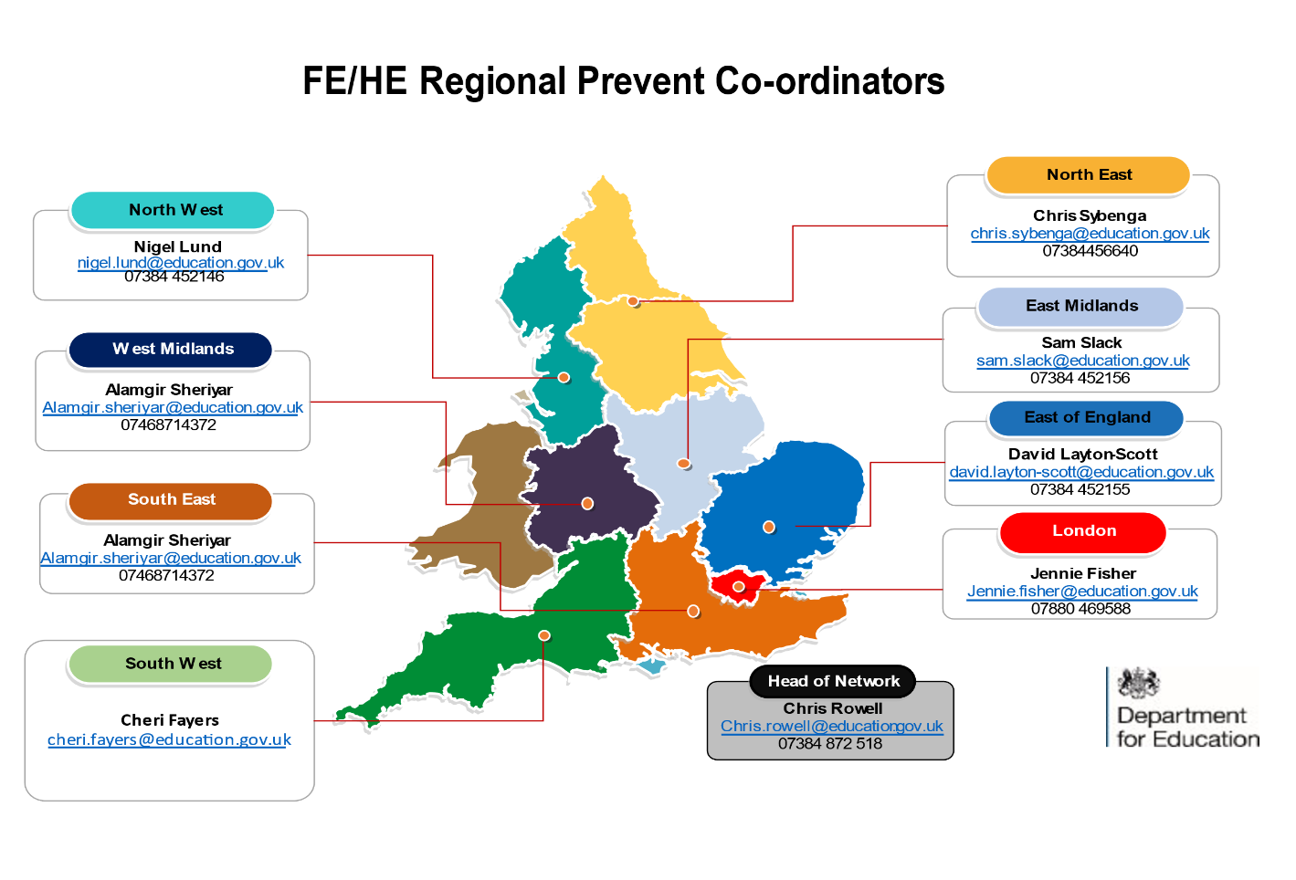

**Referral and Channel Reporting Procedure**

The Prevent Strategy identifies that young people and vulnerable adults are more likely to be vulnerable to violent extremist or terrorist narratives.

There is also nonviolent extremism this can be around vocal or active opposition to British Values. Some key areas to note may be hate crime, racism and bullying, online activity, and extreme political views.

The Channel Process ensures that all appropriate agencies are involved.

The DSL will:

* Liaise with the local Prevent Coordinator and local safeguarding boards.
* Be available for Multi Agency Channel Meetings
* Support implementation should a Channel support package
* Update APPROVED TRAINING Records and SLT (Confidentiality applied)